**Academic Pathway Optimization**

Goodfellas

IS436 - 03

Deliverable 2

March 27th, 2019

**Project Members**

Paul Lyon

Tanner Yatsko

Jas Singh

Zach Jaquet

Benjamin Wang

Densu Kurian

William Chanmugam

Niels Verhoeven

**Requirement Definition Document**

This deliverable focuses on the functional and non-functional requirements that were determined by various data gathering methods including interviews and document analysis. Three freshman and two managers were interviewed for their input and a document analysis was run on various sources that are currently related to what our system does.

**Interviews**

**Manager Interviews**

There were two manager interviews, one was Carlos Mckinney who is a senior lecturer for information system related course work. Another was Oscar Urquiza who is a residential assistant for Hillside Apartments. These two interviews were the most helpful for determining functional and non-functional requirements. It was found that the software should be kept simple, easy to use, and mobile friendly. A non-complex system allows high success rate in which the application can be used. We should offer a way to quick save or download the pathway a user has created so the user can share or store the template they created. The application should have the least number of barriers to use; no email verification, no student requirement. This allows people who are younger to anticipate and get an idea of what they maybe want to study in college. Software should provide some bias on coursework suggesting that a class is more “difficult” and requires more “work” to get an A or passing grade in the class. A list of functional and non-functional results we obtained from each manager is provided in the table on the next page. Check the appendix (pg. 19-22) for the copy of the interviews in their original format, the time and locations, and the questions asked.



**Freshman Interviews**

A group of three freshman UMBC students were interviewed to get an actual potential user perspective. These included the students Soraya Chaiyakul, Jeril Varghese, and Irene Thomas. Two had already decided on a major while one was clueless. The main function that was emphasized was the capacity to produce a full 4-year schedule with detailed information about the difficulty, professors, and course load required for each major/program. Being available anytime was also a requirement as regular advisors can have inconvenient schedules not very compatible with student schedules. Also, possibly calculating a schedule for graduating early was mentioned. A list of functional and non-functional results we obtained from each student is provided in the table on the next page. Check the appendix (pg. 23-28) for the copy of the interviews in their original format, the time and locations, and the questions asked.

|  |  |  |  |  |  |
| --- | --- | --- | --- | --- | --- |
| **Student Interview** | Soraya Chaiyakul |  |  |  |  |
| Functional | | Non-Functional | | | |
| **Process Oriented** | **Information Oriented** | **Operational** | **Performance** | **Security** | **Cultural and Political** |
| Determine major, minor, and classes best fit for a specific student | Professors teaching each class | Able to edit/ add interests by loging in | Available anytime | Password protected | Difficulty level for courses might be different (language courses, international History classes) |
| Help students determine their interests and what they want to do in the future | Courseload, income, and difficulty of majors | Able to keep track of the users completion of courses | Should store user infor throughout college | User information must be confidential | Language barriers |
| Capacity to plan out classes |  |  |  |  |  |

|  |  |  |  |  |  |
| --- | --- | --- | --- | --- | --- |
| **Student Interview** | Jeril Varghese |  |  |  |  |
| Functional | | Non-Functional | | | |
| **Process Oriented** | **Information Oriented** | **Operational** | **Performance** | **Security** | **Cultural and Political** |
| Plan out classes for 4 year term | Information on professors | User friendly | PC and mobile | Information must be confidential | International students might have conflicts |
|  | Courseload, income, and difficulty of majors | Easy to navigate and re enter information | Can store multiple searches from single user | Password protected | Difficulty level for courses might be different (language courses, international History classes) |
| Make an account | Summer and winter course schedule | Able to keep track of the users completion of courses |  | Open to public to a limit | Some advisors might not like the idea |
| Show the requirements for each degree | Year(freshman, sophomore) the course is usually taken |  |  |  |  |

|  |  |  |  |  |  |  |
| --- | --- | --- | --- | --- | --- | --- |
| **Student Interview** | Irene Thomas |  |  |  |  |  |
| Functional | | Non-Functional | | | |  |
| **Process Oriented** | **Information Oriented** | **Operational** | **Performance** | **Security** | **Cultural and Political** |  |
| Breakdown of requirements for academic programs | Courseload, income, and difficulty of majors | Able to save the info/interests | PC and Mobile | User information must be confidential | Language barriers |  |
| Provide course catalogue if requested | Information on courses offered | Able to edit/ add interests by loging in | Should store user info throughout college | unique password for each user | Some advisors might not like the idea |  |
| Calculate schedules involving graduating early | semesters the courses offered | Can be easily accessed through phones |  | Mainly for UMBC students | Proffessors might question application's judgment |  |
| An account to keep adding interests and editing them | when is a course usually taken by other students |  |  |  |  |  |

**Document and As-Is Analysis**

**History that led to the project**

Deciding what major to take was previously something that was decided by the student with help from an academic advisor.  Most of the time incoming freshmen are told to pick a major with limited information about what that studying that major will be like.  The outcome of this current system is that many students have trouble choosing their major and start their college career as undecided or in a major they do not like. The unfortunate outcome of this is that many students end up wasting time and money studying a major they will ultimately switch out of.  UMBC advising already has a couple options. One being the Focus2 online self-assessment tools that provide users with personalized career exploitation and planning services that are coupled with an in person advising appointment. Another service called Traitify shows a series of images requiring the user to answer “me” or “not me” to, then creates a list a careers and majors that might be helpful. Our team believes we can create a better system that will help students choose a major without the need for an in person advising interview saving students valuable time.

**As – Is Documents**

<https://careers.umbc.edu/students/discover/self/>

This page provides and links and descriptions for the following resources. Screenshots of each source can be found in the appendix. Page 12-14 for Focus2 and 15-18 for Traitify.

**Focus2**

**Site Intro:** FOCUS2: Career and Education Planning Online Assessment

“This online self-assessment tool provides you with personalized career exploration and planning services. Based on your interests, your personality, your talents and your values, FOCUS2 will provide a customized report listing careers that match these areas.

Take the FOCUS2 assessment, then, schedule a 60-minute FOCUS2 appointment with a career advisor to discuss your results.”

This source contains up to date information and contains other surveys not shown that include a work interests, personality, skills, values, and leisure assessment. Overall this web tool is easy to use and contains tools that go beyond the scope of our current project because it puts a large focus on career planning and allows students to keep track of the academic progress.

**Traitify**

**Site Intro**: “Get to know yourself with Traitify’s fun visual personality assessment. Simply click “Me” or “Not Me” on a series of images, and in a matter of minutes get recommendations on career paths based on your personality and preference data. Our Career Specialists can also help you interpret your results, begin exploring your pattern of strengths and clarify your career path. Schedule a 60-minute appointment with a Career Specialist to talk further.”

This online tool is simple, fast and easy to use.  The tool consists uses a picture of concept and asks the user to choose “me” or “not me”.  After you finish the survey the site provides a detailed list of your varying personality traits along with a description of those personality traits. After showing you all your personality traits, it generates a list of different career matches that would well with your personality type. This test differs from our project in that it focusses more on personality type and is more directed at choosing a career instead of choosing a given major.  This tool can useful for our project and is a good example of an easy to use program.

**Flowchart of As-Is Option**

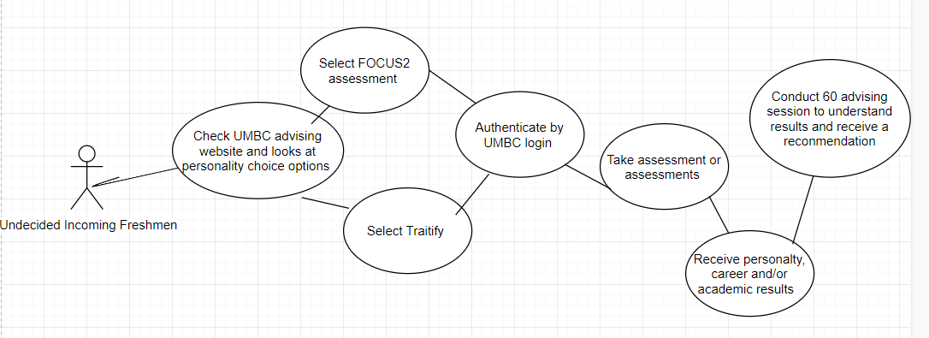

**Case Study Diagram**

Below is the case study diagram we derived to be best fit for our functional and non-functional requirements that we can reasonably implement within this semester:

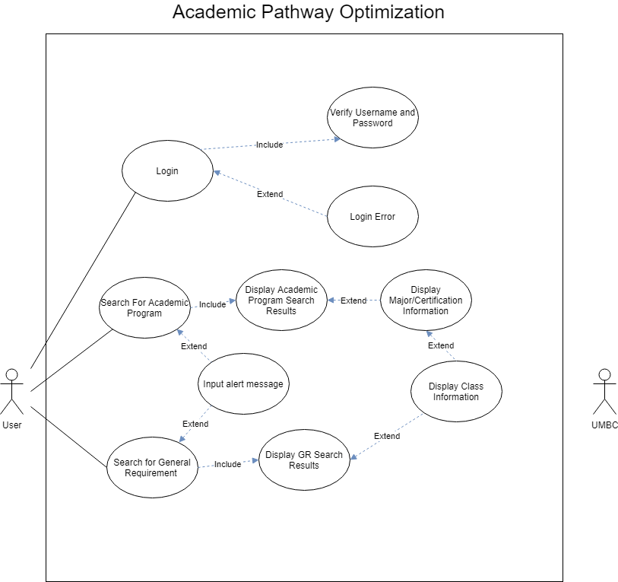

**Case Studies**

Below are the case studies for the major use cases.

|  |  |  |  |  |  |
| --- | --- | --- | --- | --- | --- |
| **Use Case Name:** | Login | **ID:** | 1 | **Priority:** | Very High |
| **Actor:** | Site User/Student | | | | |
| **Frequency:** | Required | | | | |
| **Description:** | User inserts username and password for account verification | | | | |
| **Preconditions:** | User is a registered student with an account username and password | | | | |
| **Trigger:** | External - User wants to access academic pathway system | | | | |
| **Normal Course:** | **1.** User inputs username and password | | | | |
|  | **2.** Username and password is checked against user database | | | | |
|  | **3.** Login is accepted or declined | | | | |
| **Include (1.1):** | *Validate username and password against student database* | | | | |
| **Extend: (1.2):** | *Reject username and password and signal user with login error page* | | | | |
| **Postconditions:** | User is validated and gains access to user case 2 and 3 | | | | |
| **Postconditions: (1.2):** | User is unable to access further user cases and is prompted to try again | | | | |
|  |  |  |  |  |  |
| **User Case Name:** | Search for Academic Program | **ID:** | 2 | **Priority:** | Optional |
| **Actor** | Site User/Student | | | | |
| **Frequency:** | Very High | | | | |
| **Description:** | User inputs various filters to search for academic programs | | | | |
| **Preconditions:** | User has successfully logged in | | | | |
| **Trigger** | Student decides to search for academic program | | | | |
| **Normal Course:** | **1. User selects and inputs filters for their search of an academic program** | | | | |
|  | **2. Search results are presented, and user selects specific program(s) for more info** | | | | |
| **Include (2.1):** | *Display academic program search results* | | | | |
| **Extend (2.4):** | *Input alert message if inputs are invalid or not filled* | | | | |
| **Postconditions (2.1):** | User can select a program for more information or make another search | | | | |
| **Postconditions (2.4):** | User must fix any invalid inputs and try to search again | | | | |

|  |  |  |  |  |  |
| --- | --- | --- | --- | --- | --- |
| **User Case Name:** | Display Search Results | **ID:** | 2.1 | **Priority:** | Subsequent to Case ID 2 |
| **Actor** | Site User/Student | | | | |
| **Frequency:** | Very High | | | | |
| **Description:** | User is presented with search results from case 2 | | | | |
| **Preconditions:** | User has made a search from case 2 | | | | |
| **Trigger** | User has made a search from case 2 | | | | |
| **Normal Course:** | **1. User checks through search results to select a fitting academic program to their liking** | | | | |
|  | **2. User clicks on program to find out more information** | | | | |
| **Extend (2.2+2.3):** | *2.2: Display program information -> 2.3 Display information on individual classes* | | | | |
| **Postconditions (2.2/3):** | User may return to search results or make another search | | | | |
|  |  |  |  |  |  |
| **User Case Name:** | Search for General Requirement | **ID:** | 3 | **Priority:** | Subsequent to Case ID 2 |
| **Actor** | Site User/Student | | | | |
| **Frequency:** | Very High | | | | |
| **Description:** | User inputs various filters to search for general requirements | | | | |
| **Preconditions:** | User has successfully logged in | | | | |
| **Trigger** | Student decides to look for general requirement classes | | | | |
| **Normal Course:** | **1. User selects and inputs filters for their search of a general requirement** | | | | |
|  | **2. User search results are presented, and user selects specific classes for more information** | | | | |
| **Include (3.1):** | *Display General Requirement search results* | | | | |
| **Extend (2.4):** | *Input alert message if inputs are invalid or not filled* | | | | |
| **Extend (2.3):** | *Extended off 3.1, display information on individual classes* | | | | |
| **Postconditions (2.3+3.1)** | User may return to search results or make another search | | | | |
| **Postconditions (2.4):** | User must fix any invalid inputs and try to search again | | | | |

**Appendix**

Page 12 – 14……………………**Focus 2 Screenshots**

Page 15 – 18……………………**Traitify Screenshots**

Page 19 – 20……………………**Manager Interview Carlos Mckinney**

Page 21 – 22……………………**Manager Interview Oscar Urquiza**

Page 23 – 24……………………**Student Interview Soraya Chaiyakul**

Page 25 – 26……………………**Student Interview Jeril Varghese**

Page 27 – 28……………………**Student Interview Irene Thomas**

**Focus 2 Screenshot**

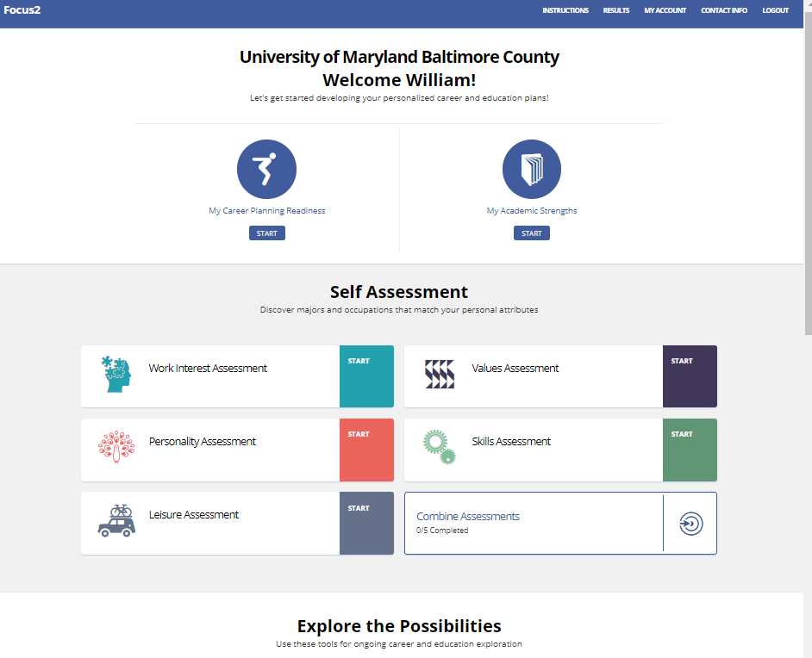

**Focus 2 Screenshot**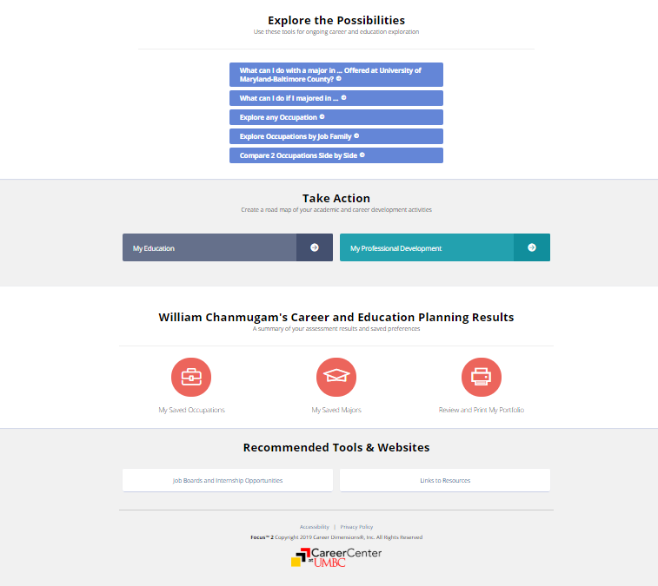

**Focus 2 Screenshot**

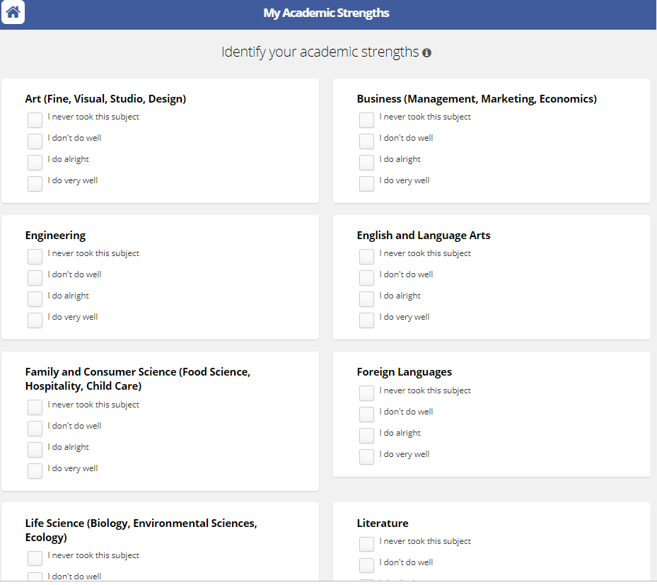

**Traitify Screenshot**

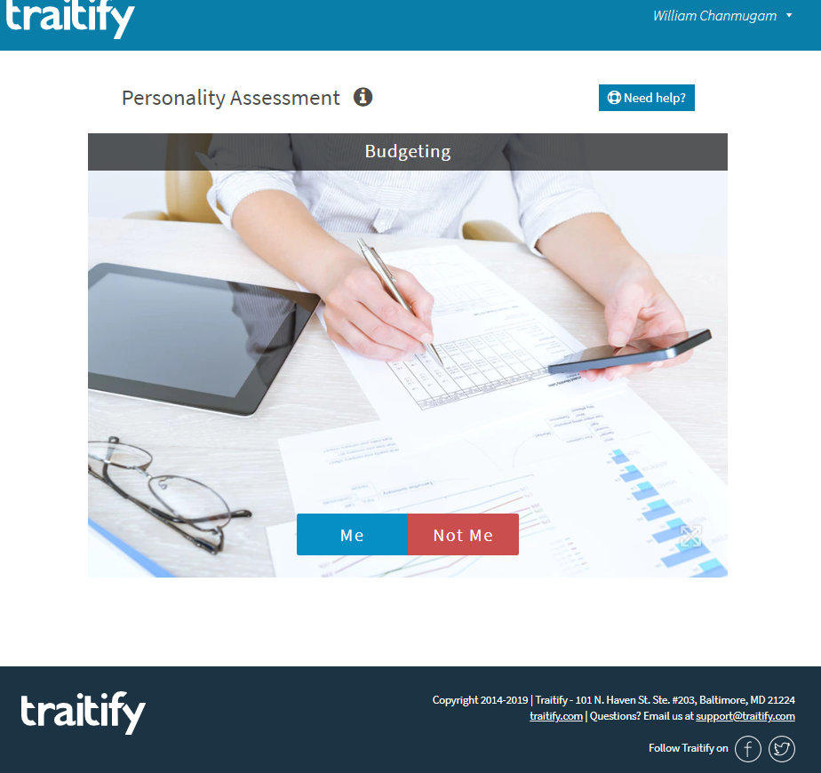

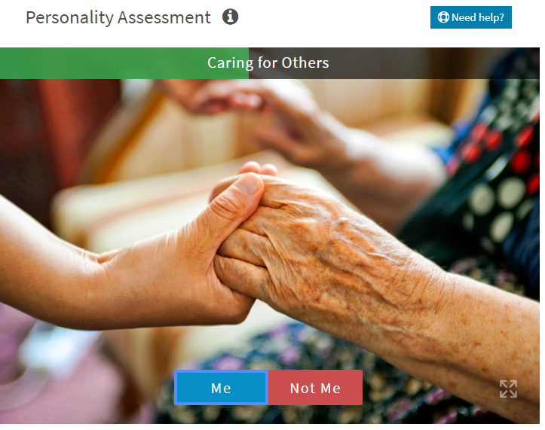

**Traitify Screenshot**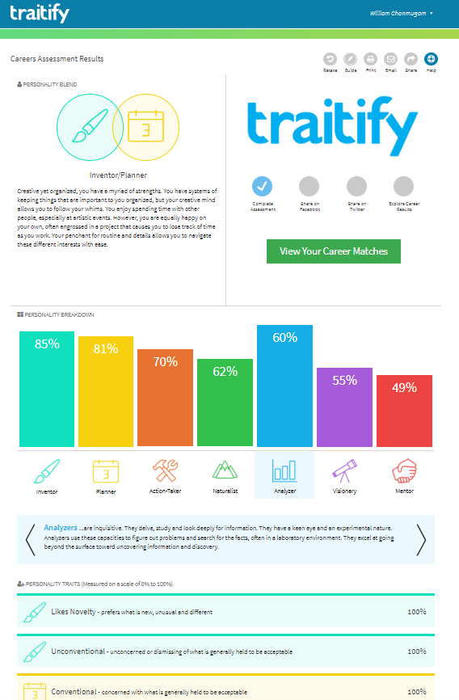 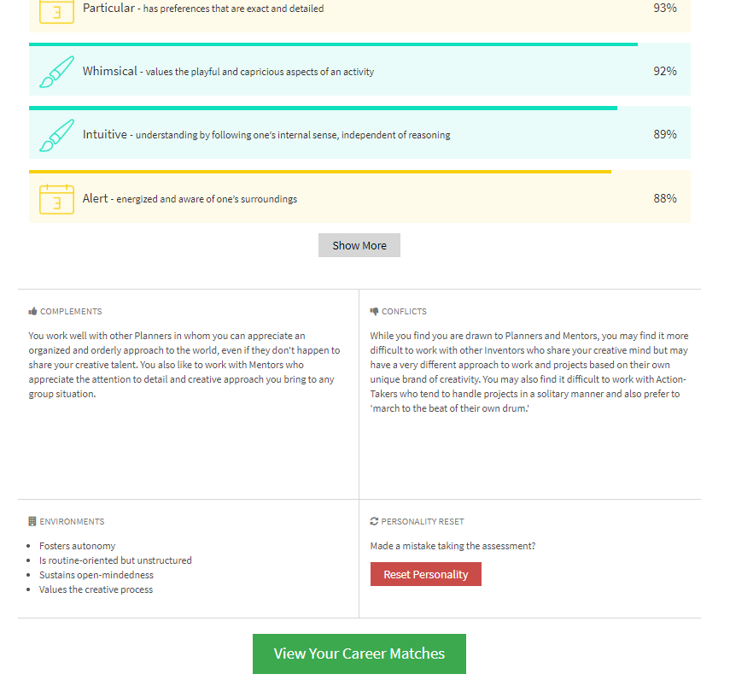

**Traitify Screenshot**

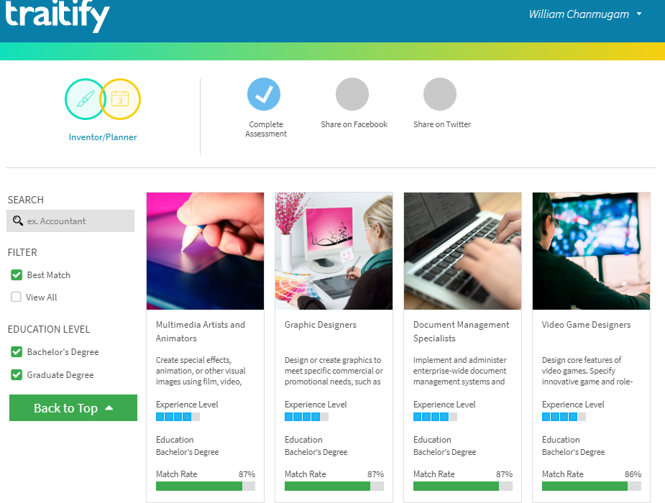

**Manager Interviews**

**Interview #1**

Interviewee: Carlos Mckinney

Position: Senior Lecturer for Information System related course work.

Time & Location: March 13th 6:45pm

Interviewer: Jas Raj Singh

Functional Questions & Responses (Non-technical)

* What information should we gather from the user before making them recommendations?
  + Interest (interested in), What existing classes have you taken, what did you enjoy in classes, childhood things you wanted to do when you “grow up”
* Should the user have to verify they are a college/UMBC student?
  + No, leaves it open to anyone who is interested in seeing what they want to do (high school students)
* Should the application tell user if classes overlap or provide multiple templates of possible schedules?
  + Order in which you would want to take classes, prerequisites, classes that are only offered in spring/fall, classes that fill up fast/ take it sooner/more urgent for your major.
* Should the application be available in multiple languages (Spanish, Chinese)?
  + Yes, would help, but adds more work.
* Should users be allowed to create pathways with multiple majors/minors?
  + Different alternatives are good, don’t want to pitch and hold someone into one “result”,
* Should the system give feedback on the likelihood of success when a user enters certain parameters? (Success = Chance of graduating)
  + “Harder” is still relative, create “math intensive majors”/ “writing intensive majors, language component” (certain classes add this (aka if you have to take calc 3 then it checks the box that says it is a “math intensive” major”))
* Should the system offer full recommended pathways (2/4-year paths)?
  + “Have part where you tell us already how many credits you have” / “having a premade sheet for classes for certain majors” - what can you do with these major/minors

Suggest a forum board to help people communicate with one another

Non-Functional Questions & Responses (Technical)

* Should the system collect cache data for users to be able to open up software again and not have to re-enter information?
  + Sure. maybe include a basic login
* How should we host? AWS/Ocean/Physical server
  + AWS is the best
* Should we collect emails and send out a verification?
  + IF you have a login then emails yes
* Should there be separate mobile development (swift, android)?
  + No
* Mobile web friendly?
  + Just make the site mobile friendly
* Offer a downloadable PDF of course/college pathway outline to device?
  + Sure, especially if they aren’t saving it
* How long should the system be up?
  + 24/7

**Interview #2**

Interviewee: Oscar Urquiza

Position: Residential Assistant for Hillside Apartments

Time & Location: Hillside Apartments 5:00 pm March 27th

Interviewer: Jas Raj Singh

Functional Questions & Responses (Non-technical)

* What information should we gather from the user before making them recommendations?
  + Parameters, age, interest, hobbies, parents’ careers/interest.
* Should the user have to verify they are a college/UMBC student?
  + Only if they want to receiver further advice/guidance from someone on campus.
* Should the application tell user if classes overlap or provide multiple templates of possible schedules?
  + It can, if those settings are checked, ideally the easiest thing to do is just create a bunch of mock templates and course outlines.
* Should the application be available in multiple languages (Spanish, Chinese)?
  + If capable and easy to do, then yes. Spanish ideally.
* Should users be allowed to create pathways with multiple majors/minors?
  + Users should be able to create a pathway with up to 1 major and 1 minor. Allowing them to create more unique pathways compared to just a normal major pathway.
* Should the system give feedback on the likelihood of success when a user enters certain parameters? (Success = Chance of graduating)
  + The system should create a scale and give an output of how many rigorous classes that user may need to take to complete that pathway. A rigorous course can be identified as one that has a high rate of drop/w/failure to complete.
* Should the system offer recommended pathways (2/4-year paths)?
  + It can create default pathways that are common majors and minors grouped. Like comp sci and a math minor, or a biology and psych minor, or Engineering and entrepreneurship minor.

Non-Functional Questions & Responses (Technical)

* Should the system collect cache data for users to be able to open up software again and not have to re-enter information?
  + Doesn’t matter, sure.
* How should we host? AWS/Ocean/Physical server
  + AWS
* Should we collect emails and send out a verification?
  + Only if they want to email their schedule or share it.
* Should there be separate mobile development (swift, android)?
  + No
* Mobile web friendly?
  + Yes
* Offer a downloadable PDF of course/college pathway outline to device?
  + Yes, especially if the software doesn’t have a login or any database to save users info.
* How long should the system be up?

24/7

**Student Interviews**

Interview #1

Interviewee: Soraya Chaiyakul

Position: Freshman at UMBC

Time and Location: March 14th 12:00 pm at Starbucks, On-campus

Open-ended Questions:

-          Do you have trouble deciding what academic path you would like to go throughout your college career? If yes, why? If no, why?

        - Yes, because I did not know what path to choose because I was unclear of what I wanted to do for the rest of my life.

-          Do you have trouble deciding what kinds of classes to take for your major? If yes, why? If no, why?

        - Yes, because I have trouble even finding out what kind of major I’d like to be in let alone what kind of classes even after meeting with my advisor many times.

-          Is meeting with your advisor convenient? If no, why?

        - No, because there was many students and it was very hard to make an appointment that matched my busy schedule.

-          What is your major? If undecided, why?

        - I am currently undecided, because I do not know what my interests are or what I would like to do for my next years here.

Close-ended Questions:

-          What are your academic interests?

        -Life science and business

-          What is your desired course load?

        -Medium

-          What is your desired income level?

        -Around 100k

-          What kind of level of difficulty would you be interested in? (Easy, Medium, Hard)

        - Medium

-          Do you know the best professors for each class?

        - Not at all

-          Do you have all your classes planned out for the remaining years?

        - No

Concluding Questions:

-          What if I told you we had an application that will be able to satisfy all your preferences to make choosing the best-fit academic pathway more convenient? Would you use it? If yes, why? If no, why?

- Honestly, that sounds like a dream come true. I would definitely use it because it seems like it would get me closer to helping me choose what academic path I would like to go on. Any help would be appreciated and all of the professors and classes that will be planned out for the years to come would be extremely useful!

- What would want an app like that to do?

I would also like to be able to edit my account throughout my career. I think it would beneficial for everyone including you if you could keep track of users completion of the courses.

- What kind of information would you want from it?

I would like to know what courses are taught by each professors and get more details on the course load of each degree and difficulty of majors.

- What kind of security would you be expecting?

I want my account to be password protected. I believe it is crucial that you make all these information confidential

- Do you think there are going to be cultural barriers or political issues?

Difficulty level of courses will be different for each student. Like someone with a spanish background might think a spanish class is easy while it might be hard for others. UMBC is a diverse campus so language barrier might play a role too.

INTERVIEW 2:

Interviewee: Jeril Varghese

Position: Freshman at UMBC

Time and Location: March 25th 9:30am pm at Starbucks, On-campus

Open-ended Questions:

-          Do you have trouble deciding what academic path you would like to go throughout your college career? If yes, why? If no, why?

No I do not have trouble deciding what academic path i want to go through with.I have known since I was very young that I have a specific interest in the science field and as I grew up I realized I wanted to help people while working in the science field. In order to be in the science field and help people I decided in high school I want to work to become a doctor.

-          Do you have trouble deciding what kinds of classes to take for your major? If yes, why? If no, why?

No because there is a clear template of classes required for my major on the UMBC website

-          Is meeting with your advisor convenient? If no, why?

Yes, he is very helpful and very convenient to meet up with.

-          What is your major? If undecided, why?

I am a Biology B.S. major and a psychology minor

Close-ended Questions:

-          What are your academic interests?

I like science So I enjoy taking biology classes and chemistry classes. I enjoy organic chemistry the most.

-          What is your desired course load?

18 credits per semester

-          What is your desired income level?

70,000 per year

-          What kind of level of difficulty would you be interested in?(Easy, Medium, Hard)

Medium

-          Do you know the best professors for each class?

Yes, I make sure to look at rate my professors website before taking a class with a specific professor

-          Do you have all your classes planned out for the remaining years?

I have most of my classes planned out for all four of my academic year

Concluding Questions:

-          What if I told you we had an application that will be able to satisfy all your preferences to make choosing the best-fit academic pathway more convenient? Would you use it? If yes, why? If no, why?

Yes I would because knowing what pathway is very important and knowing it as soon as possible is very beneficial so that there is no need to waste time in undergraduate.

- What would want an app like that to do?

I would definitely make an account if I could. One main thing I struggle with is understanding the requirements for each degree. But I would like it to be easy to use and navigate. It would be helpful if it can be accessed through phone as well.

- What kind of information would you want from it?

I would like to get more information on my professors like ratemyprofessors and more information on courseload income, difficulty of majors and when the courses are offered etc

- What kind of security would you be expecting?

I want all my information confidential. I remember you mentioning I would have to make an account so it would also be password protected. As long as no one else has access to my information I do not mind having it open to public

- Do you think there are going to be cultural barriers or political issues?

It might be harder for some students to understand the whole process, mainly the international students. Like some classes we consider hard might be easily for them. Also, just keep in my to keep the advisors updated as some of them might not like the whole idea of giving “advice” online.

INTERVIEW 3:

Interviewee: Irene Thomas

Position: Freshman at UMBC

Time and Location: March 26th 7:00pm pm at Commons, On-campus

Open-ended Questions:

-          Do you have trouble deciding what academic path you would like to go throughout your college career? If yes, why? If no, why?

No i don't have any trouble deciding what i want to do. I knew what i wanted to do right after i graduated high school.

-          Do you have trouble deciding what kinds of classes to take for your major? If yes, why? If no, why?

No i don't have any problem in deciding what classes i need to take because i read the school website and the course catalog for my major. It breaks down in terms of the classes that i need for my major.

-          Is meeting with your advisor convenient? If no, why?

Yes

-          What is your major? If undecided, why?

Information Systems

Close-ended Questions:

-          What are your academic interests?

Mathematics

-          What is your desired course load?

15-18 credits per semester

-          What is your desired income level?

$70-80,000.00 per year

-          What kind of level of difficulty would you be interested in?(Easy, Medium, Hard)

Medium to hard because i would love to challenge myself.

-          Do you know the best professors for each class?

Yes i do because i usually look up the professor that will be teaching through rate my professor.

-          Do you have all your classes planned out for the remaining years?

Yes i do have it planned out through the help of course catalog

Concluding Questions:

-          What if I told you we had an application that will be able to satisfy all your preferences to make choosing the best-fit academic pathway more convenient? Would you use it? If yes, why? If no, why?

Yes i would use it because it’s simple, the earlier you know it the earlier you graduate and don’t waste time. I would also use it because there can be more benefits such as graduating early.

- What would want an app like that to do?

On top of everything else we had already talked about I think it would be good if we can add/edit interests whenever we want and make changes to our account. I love using apps on my phone rather than navigating on a PC so it should be mobile friendly if possible. It would also be nice if we could use it to track my whole college career.

- What kind of information would you want from it?

I would definitely want more information on courseload income, difficulty of majors and when the courses are offered etc. Also like more information than the school offer on courses itself. It would be also helpful to know when these courses are usually taken by other students.

- What kind of security would you be expecting?

Of course I want my information to be confidential also probably password protected. You had said it might be open to public which would mean it might not be that accurate or specific and might be prone to attacks. I think it should mainly be for UMBC students.

- Do you think there are going to be cultural barriers or political issues?

There is definitely going to be language barriers among students. It is also possible that some professors might not agree with your/ your apps judgement so just be aware of that.